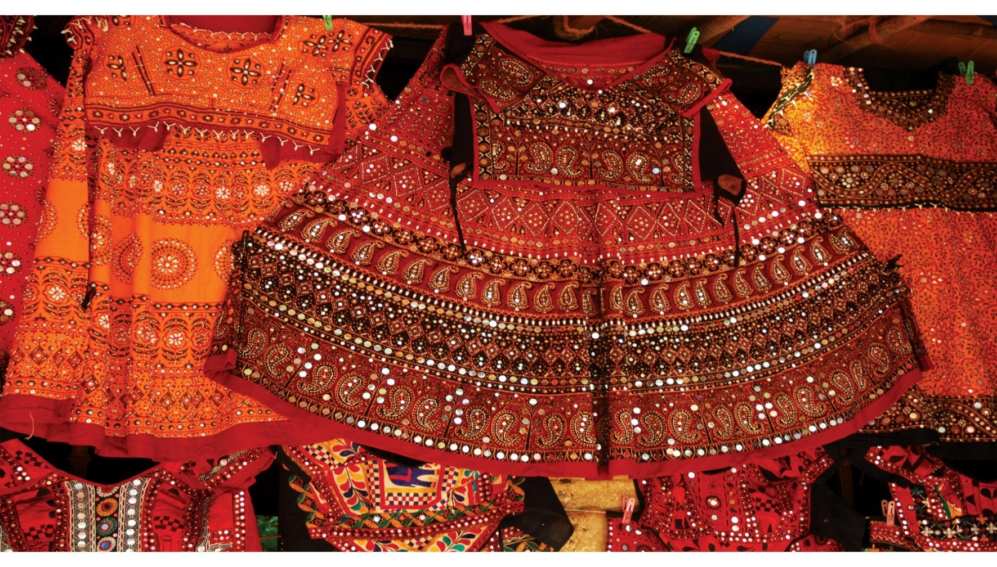[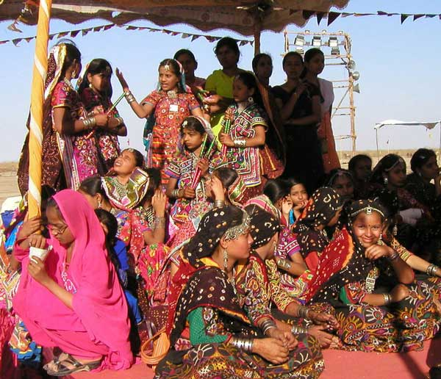](http://www.google.co.in/url?sa=i&rct=j&q=&esrc=s&source=images&cd=&cad=rja&uact=8&ved=0ahUKEwjXn7r63PHVAhULsI8KHbutDC0QjRwIBw&url=http://www.gujaratorbit.com/festivals-in-gujarat/kutch-desert-festival/kutch-desert-festival.html&psig=AFQjCNHbeFRBx5OY3ufsAqmOaV8I030fBA&ust=1503727787871497)  
**Itinerary**

**11 Nights/ 12 Days – Gujarat Cultural Tour**

**Mumbai – Surat – Vadodara – Ahmedabad – Bhuj – Hodka – Mandvi – Bhuj**

**(DAY 01) MUMBAI - SURAT**

Arrive Surat from Mumbai / Delhi

Surat is well-known as a Diamond Hub of the World. Surat is renowned for its diamond and textile industries. It is also known for producing textiles including silk. It is also known as Silk City of India. On the other hand, it is also known for its food, which includes "ghari" (a type of sweet), locho, petis, undhiyu, rasaawala khaman, and surati Chinese and many more sweets and dishes. The foremost Hindu festivals are celebrated are Navratri, Diwali and Ganesh Chaturthi. The kite-flying festival is one of the famous festival of Gujarat.

Balance day at leisure for independent activity

**Overnight at hotel**

**(DAY 02) IN SURAT**

Full day tour of Surat visiting **Dandi** situated on the coastline and well known as a salt centre, Dandi has acquired a name in history after the famous Dandi March Salt Satyagraha launched by Gandhiji in March, 1930 A.D

Later visit **Old fort** & **textile market**.

**Overnight at hotel**

Post breakfast drive to Vadodara.

**(DAY 03) SURAT - VADODARA**

Vadodara is a graceful city of palaces, parks, temples and museums and considered by many as the de-facto cultural capital of Gujarat. Once the capital of the Gaekwads, the former rulers of Vadodara, it is also known as Baroda and rises from the banks of River Vishwamitri. Vadodara is also the industrial capital of Gujarat.

Upon arrival check in at Hotel.

**Afternoon sightseeing tour of Vadodara visit the Palaces, Temples and Museums.**

**Overnight at hotel**

**(DAY 04) VADODARA - AHMEDABAD**

Morning after breakfast leave Vadodara for Ahmedabad enroute visiting Champaner and Pavagadh.

**Champaner** is an ancient fort located at the foothills of Pavagadh. The town derives its name from the Champa tree or from Champaraj founder of the town, a contemporary of King Vanraj Chavda of Anhilwada.

Muhammad Begada decided to establish the new capital of Gujarat at this place in 1484 AD and changed the name of the town to Muhammadabad. It took 23 years to built the town and had a meteoric rise and attained glory as a great town of western India. Many edifices were constructed during these years : bazaars,town squares, Royal Gardens and water structures, including mosques. It also became a major trading center producing fine silk, woven and dyed textile and sword manufacturing.

Its decline started after attacks by the Mughal Emperor Humayun in 1535 AD. After the death of Sultan Bahadurshah (1536 AD), the Royal Capital was again moved back to Ahmedabad. Later, the fort came under control of Mughals, Marathas and British; but Champaner could never regain its glory. In 1803 AD, when the British took the town, it was overgrown with jungles and had only 500 inhabitants.

**After the visit drive to Ahmedabad**.

**Ahmedabad:** This city which was named after sultan Ahmed Shah, who founded it 1411 and is known as one of the fastest-growing cities in the Western region of India. The leader Mahatma Gandhi resided in Ahmedabad. This city was one of the major and the most important cities during the nationalist movements that took place when our nation was fighting for freedom. For city sightseeing in Ahmedabad, the beautiful Jumma Masjid must be visited to experience the history of this city. The famous Dandi March had started from the very famous spot known as the Sabarmati Ashram built on the banks of the Sabarmati River.

**Check-in at your hotel in Ahmedabad for 2 nights.**

**Overnight at Hotel.**

**(DAY 05) IN AHMEDABAD**

Breakfast at hotel.

After breakfast, take a heritage walk through the old city. Founded in 1411 by Ahmed Shah I on the site of the ancient city of Karavati, Ahmedabad is today the great textile and commercial city of western India.

There is Sabarmati River over which four bridges connect the old city with the new. On one side are the crowded streets leading to Manek Chowk, where rows of traders dealing in silver jewellery or printed fabrics lean against spotless white bolster-pillows, waiting for customers. The upper floors of the old havelis (family homes) have exquisitely carved wooden balconies, windows and doorways. The most beautiful ones stand in **Doshiwala ni Pol**. Visit world renowned **Calico Textile Museum** (Closed on Wednesday & bank holidays, open from 10.15am-12.30pm & only 20 pax per day allowed with prior bookings).

In Ahmedabad, the Indo-Saracen architecture blends beautifully Hindu and Muslim styles. **Sidi Saiyad's Mosque** is one of the most eloquent examples of the finest such work in sandstone. Later visit local sites related to textile activities. Spend a few contemplative moments at **Hridey Kunj**, Mahatma Gandhi's austere Ashram set amongst mango trees where he experimented in nonviolent methods of political struggle.

The **Adalaj Vav (step well)** is located 18 kilometers north of Ahmedabad in the quiet village of Adalaj. This **vav** has served as a resting place for hundreds of years for many pilgrims and caravans along their trade routes. The **vav** is a spectacular example of Indo-Islamic architecture and design.

In the evening, continue on to the **Vechaar Utensil Museum (Closed on Mondays, best time to visit is from 7-10 PM along with dinner at Vishala Village Restaurant, a 15-minute drive out of Ahmedabad**, which houses a remarkable collection of metal ware: utensils of every imaginable shape and size in bronze, brass and other alloys have been collected from every corner of Gujarat. A traditional Gujarati meal at the Vishala Restaurant is delicious and appropriately rounds off the visit to the museum.

**Overnight at Hotel.**

**(DAY 06) AHMEDABAD - BHUJ**

After breakfast, drive to Bhuj.

**Bhuj** is a municipality and a city in Gujarat. Rao Hamirji established it in 1950. On 5th January 1548, Vikram Samvat formally laid its founding stone as the state capital. Bhuj has a history of being attacked, then conquered or defended. Kutch state was allowed into the dominion of India after independence in 1947. Kutch was combined with Bombay in 1956, which then in 1960 was parted into Gujarat and Maharashtra, two new linguistic states. Bhuj was made the district headquarters of Kutch district, when Kutch district was made a part of Gujarat. In 2001, the city was struck by yet another major earthquake, which cost many lives and much property. Bhuj is famous for Rann Utsav (Great Rann of Kutch). It takes place in December and continues till February. Music, handicrafts and music garnish the carnival that pulls tourists from around the world. The White Desert attracts numerous tourists despite being just an immense salty land.

Afternoon visit Bhujodi Village.

Overnight at Hotel.

**(DAY 07) IN BHUJ**

After breakfast, explore Bhuj visit the Aina Museum ( Closed on Thursdays) . **Rao Pragmalji’s Old Palace**, built in traditional Kutchhi style, in a small, fortified courtyard in the old part of the town, was a beautifully presented museum. It was, unfortunately, destroyed during the earthquake of 2001. The **Maharao Singh Madan Museum**, which had a varied collection of paintings, photographs and embroideries as well as a collection of old princely-state coins minted from the 17th century right up to 1948, was also severely damaged.

The **Kutchh Museum** was founded in 1877 by Sir James Fergusson, a governor of Bombay under the British Raj. The oldest museum in Gujarat, it had an excellent collection, which included anthropological and archaeological finds, textiles, weapons, musical instruments and a picture gallery.

Later spend full day visiting the **villages around Bhuj** to get a glimpse of various pastoral nomads, their lifestyle, arts and crafts. The region is renowned for its silverware, tie-and-dye fabrics, weaving, block-printing and particularly its fine needlework. **Banni** is the Arabic name for needlework and legend has it that the inhabitants came from Saudi Arabia in the 10th-11th century to settle in this region.

**Overnight at Hotel.**

**(DAY 08) BHUJ - HODKA - BHUJ**

Full day excursion to Hodka.

Hodka village is believed to have been set up by the 'Halepotra' clan from Sindh who were cattle herders in search of pastures. The Meghwals, traditional leather craft and embroidery craftspersons, from further north, have also settled in Hodka over time.  
  
Discover the Great Rann of Kutch and live with its communities in Hodka's Village Resort, the Shaam-e-Sarhad (Sunset at the Border). It is owned and operated by the Village Tourism Committee of Hodka village. A rural yet incredible experience is certain at this resort with its majestic natural surroundings and warm hospitality from locals who feed you heartily, share their culture and showcase their craft.

**Overnight at Hotel.**

**(DAY 09) BHUJ – MANDVI**

Post breakfast drive to Mandvi.

Mandvi was founded as a port town by the Khengarji, the king of Kutch, in 1574. The first temple to be built was the Sundarwar temple, followed by the Jama Masjid in 1603, the Lakshminarayan Temple in 1607, the Kajivali Mosque in 1608 and the Rameshwar Temple in 1627. For all of this to have been built in the first 50 years of the towns existence is a clear indicator of its importance to the kingdom. Indeed, at its peak, Mandvi's wealth easily surpassed that of the capital at Bhuj, and it was only after ships grew too large for its harbor and began to prefer Mumbai that Mandvi started fading from the scene.

For 400 years, the shipbuilding industry has been the center of life in Mandvi. It was once the principal port of Kutch and of Gujarat. At its peak, exports were said to outnumber imports fourfold, and their revenue reflected that. Ships came and went from East Africa, the Persian Gulf, the Malabar Coast (now called Kerala, in south India), and South-East Asia. During Rao Godiji's reign in the 1760's, he built and maintained a fleet of 400 ships, one that sailed as far as England and returned. The city used to have 8 m. fortified walls around it, but only small portions remain.

In 1929 the Vijay Vilas palace was built by Rao Vijayrajji, and is maintained in excellent condition today. The British Political Agent based in Bhuj had summer quarters at Mandvi, and the British cemetery attests to the extended presence of the British in the area.

**Overnight at Hotel.**

**(DAY 10) IN MANDVI**

Full day explore the town.

A visit to the beach, exploring the shipbuilding area, a walk along the river; all these are indispensable. But the town is also easily explored on foot, and it is well worth wandering the narrow streets to check out the mix of old architecture. Many wealthy barons during the city's heyday had flamboyant houses built, with lots of European influence; it is not uncommon to see carved angels, or stained-glass windows. The many bazaars, where all kinds of goods can be found, from bandhani textiles to tasty fresh produce, should not be missed. Specific points of interest are as follows:

**Overnight at Hotel.**

**(DAY 11) MANDVI - BHUJ**

Post breakfast drive to Bhuj.

Check in at Hotel.

Balance day at leisure.

**Overnight at Hotel.**

**(DAY 12) BHUJ - MUMBAI & FLY OUT**

Morning transfer to airport to connect flight for Mumbai & then to international airport